**13. Create a Virtual Machine with 1 CPU, 2GB RAM and 15GB storage disk using a Type 2 Virtualization Software using Vmware workstation.**

STEP 1 :click on create resource and type for vm

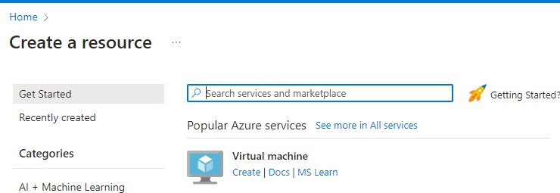

step 2 : able to see all 8 tabs avaible in virtual machine

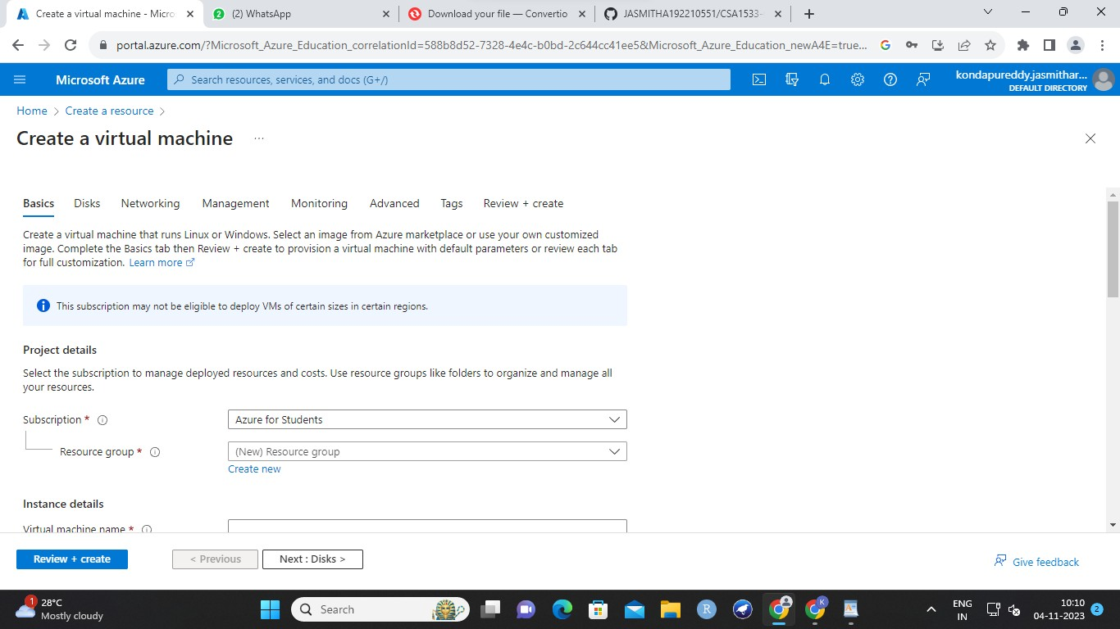

step 3 :

enter any name and write azure name

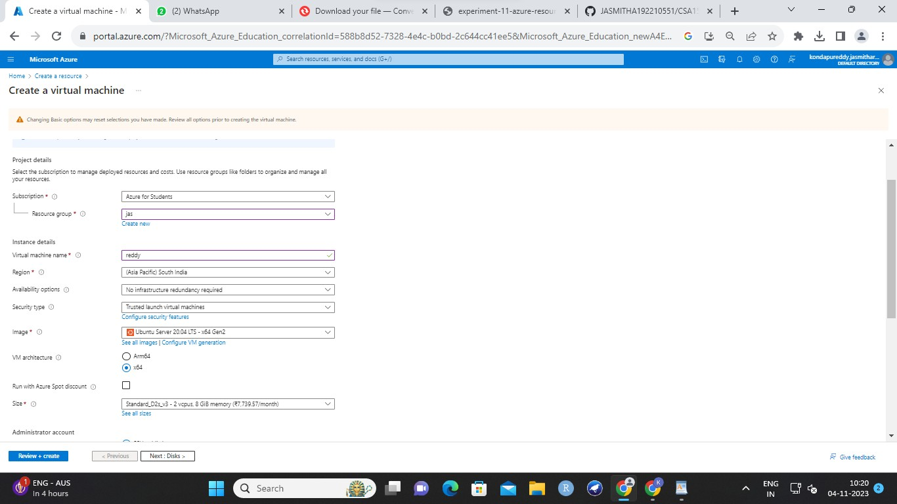

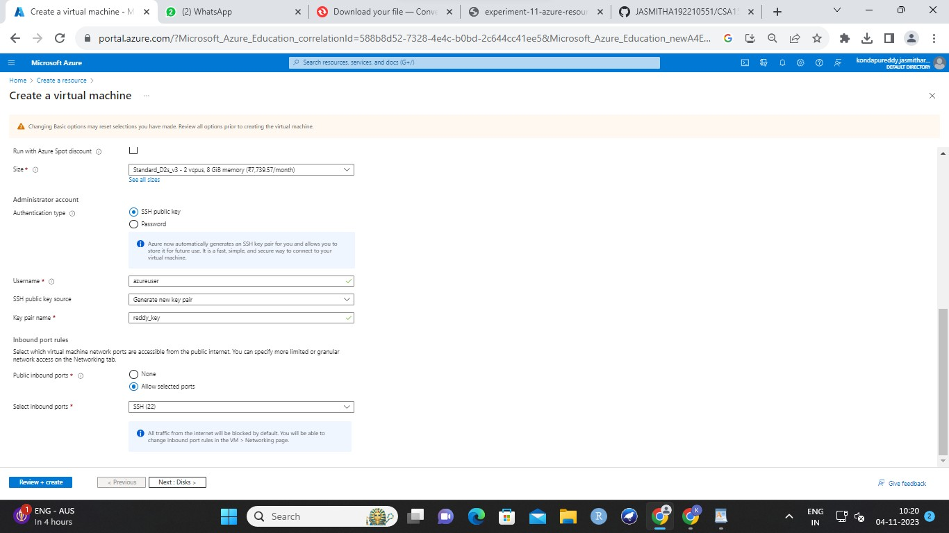

step 4 : enter data in disk

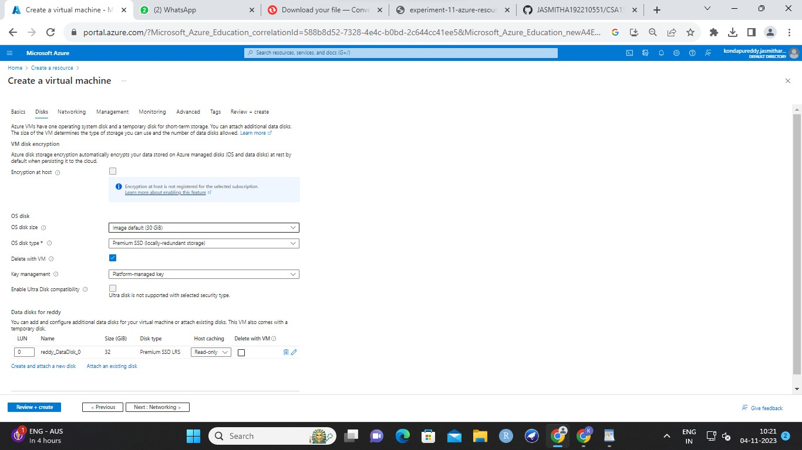

step 5 : go for networking

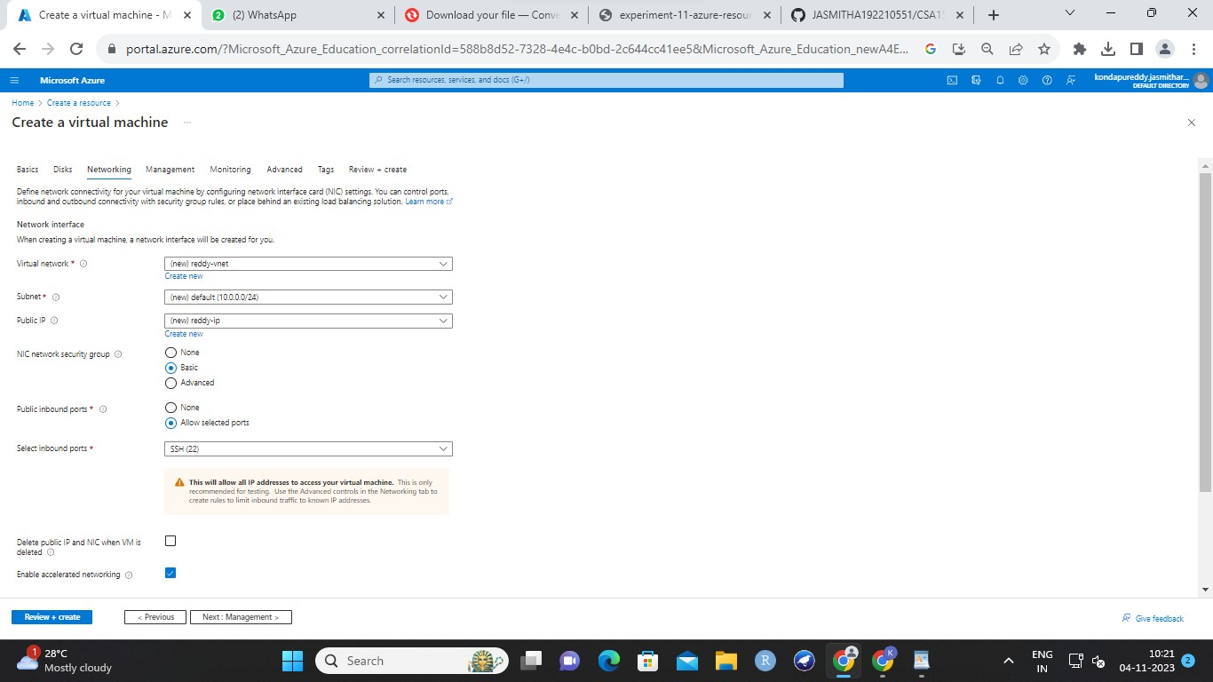

step 6 : then management and default

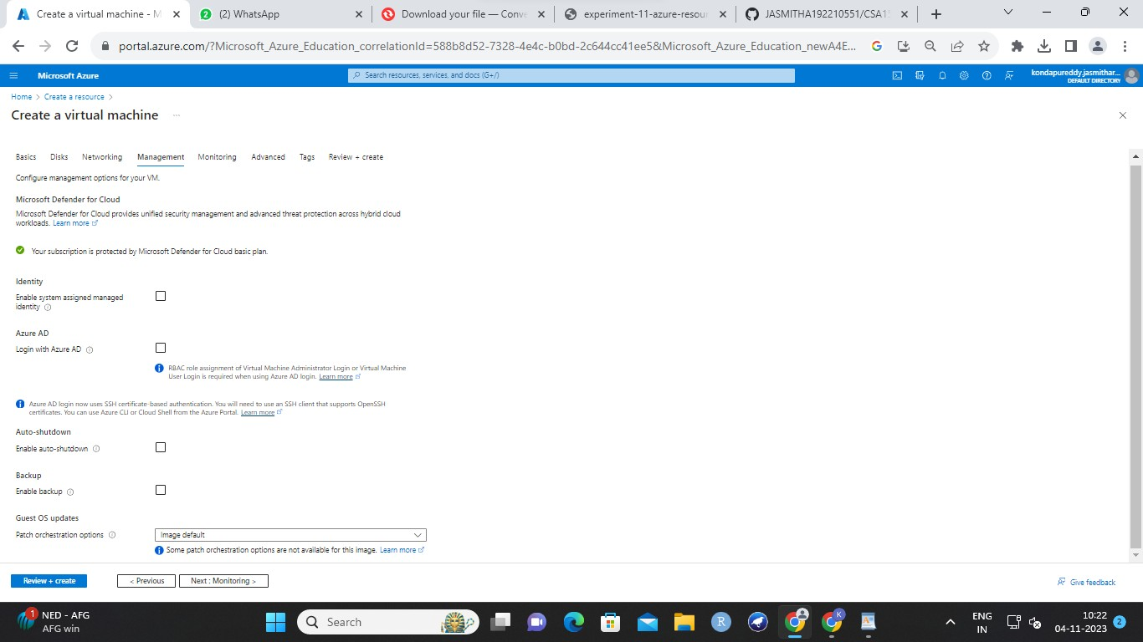

step 7 : deafault monitoring

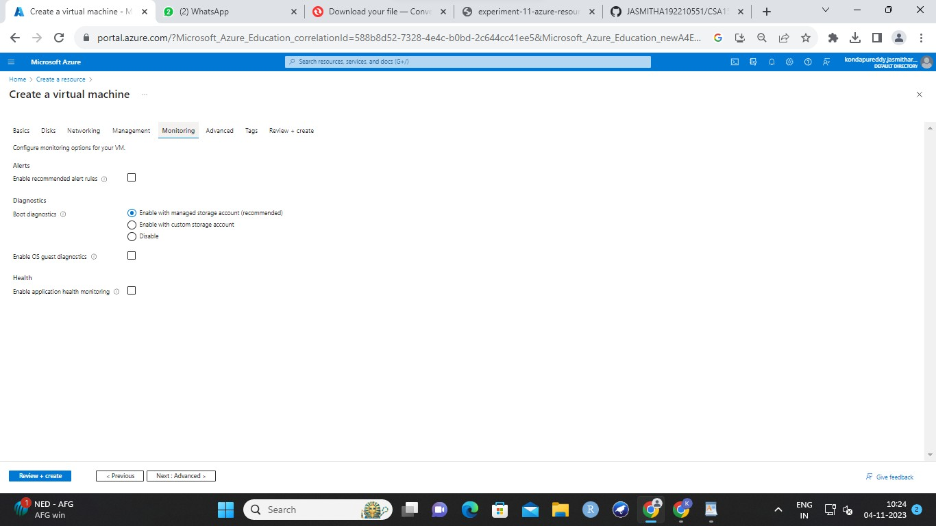

step 8 : default advanced

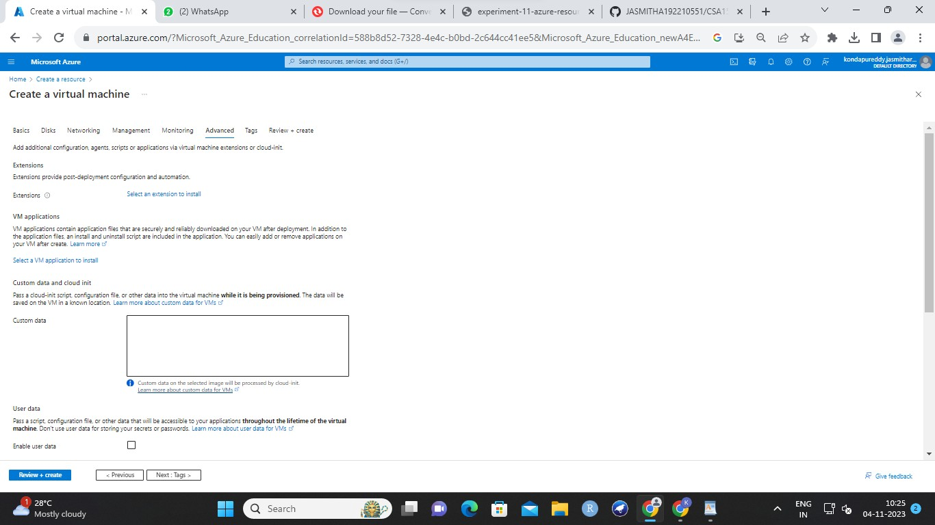

step 9 : enter data in tags

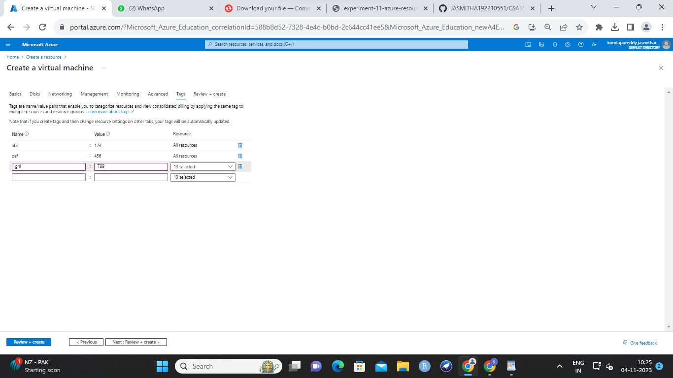

step 10 : review

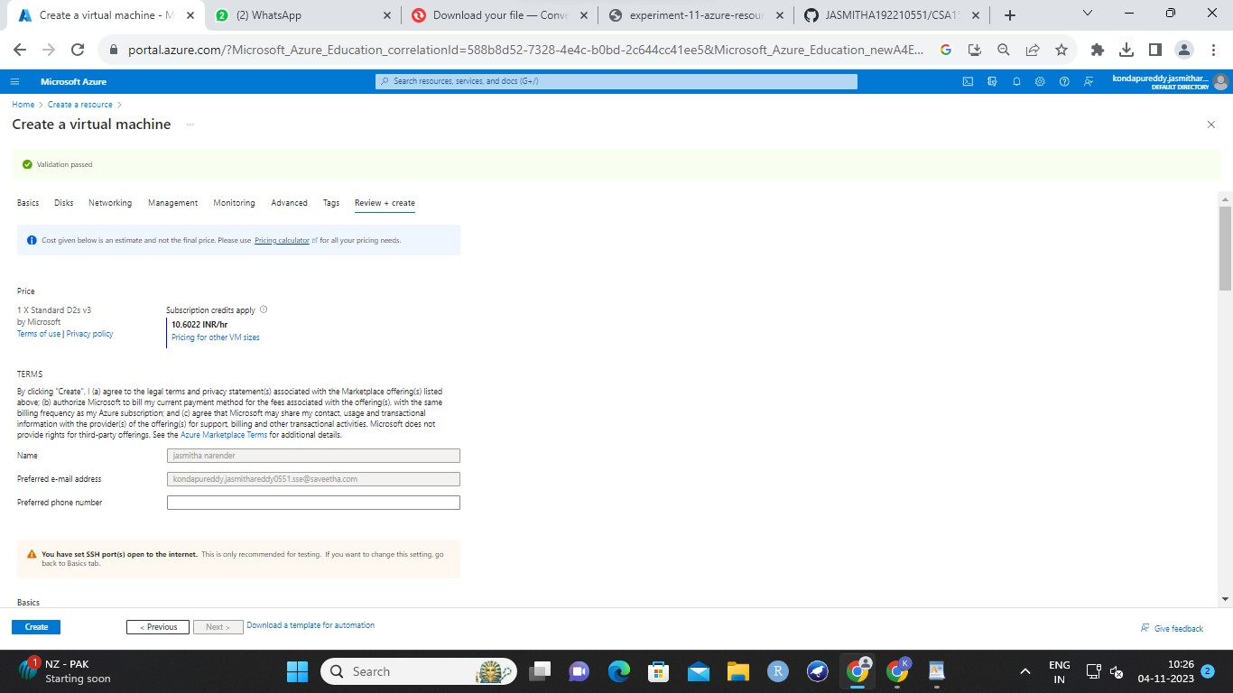

step 11 : result

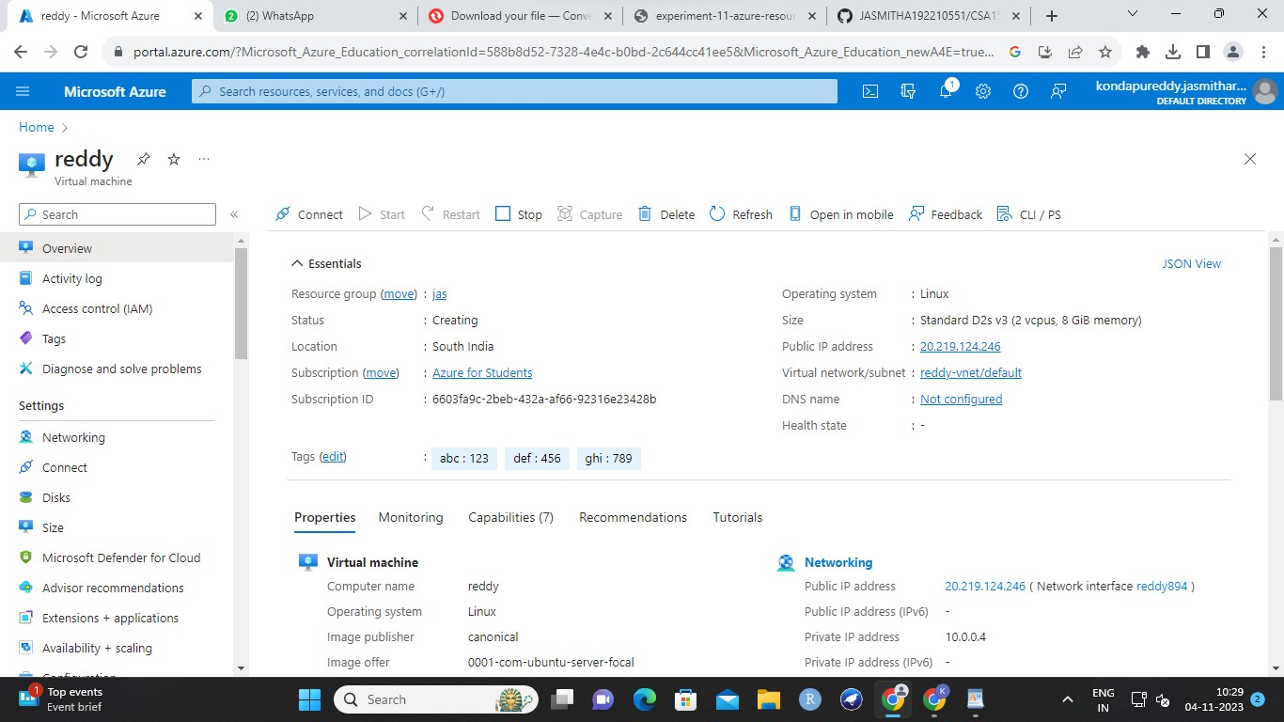

step 12 : connect

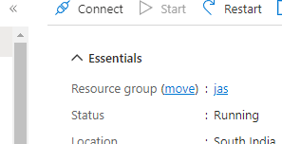

step 13 : select ssh



step 14 : give tick and agree

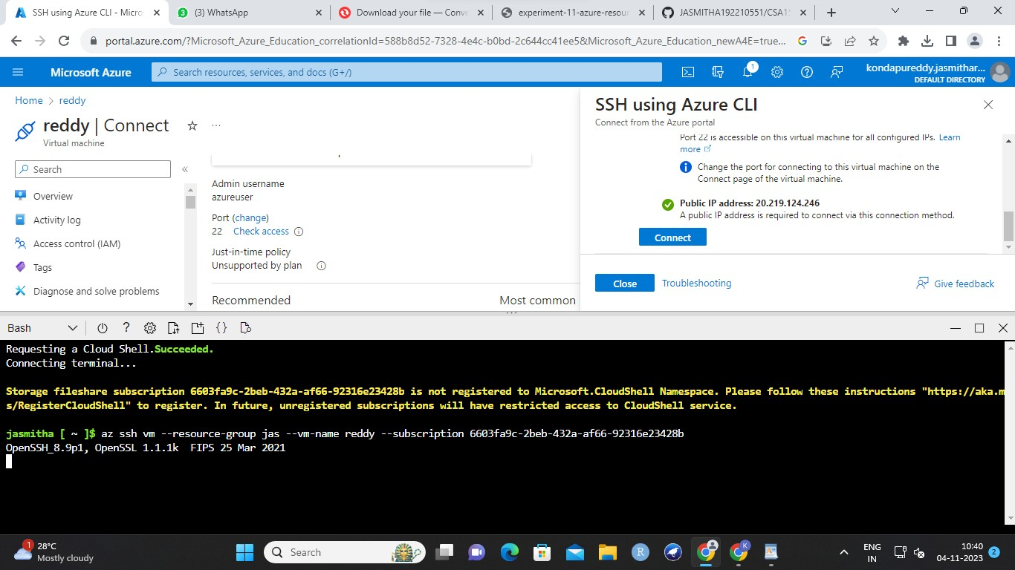

step 15 : getting a bash and then type yes and once pur saveetha mail is shown experiemnt got done

